RDBMS Design and Transaction
Ice Ybanez
R00176611
SDH2-B
Question 1
- Conceptual Diagram
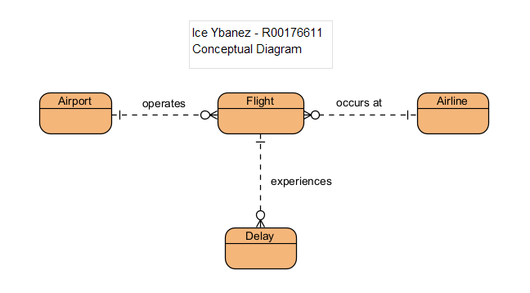
- ERD
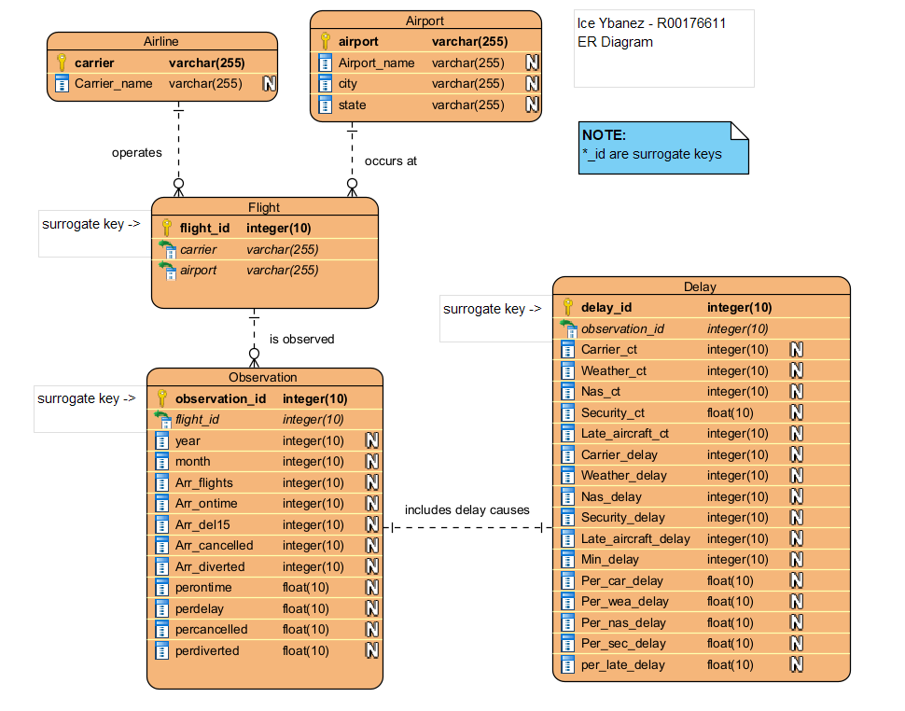
Question 2
1.
Employee_T.employeeID
Reason for indexing:
It’s used in the JOIN condition. It’s the primary key for Employee_T and the database uses it to match records with Performance_T.
Indexing speeds up lookups when joining. (Can’t assume it’s already present)

Employee_T.employeeName
Reason for indexing:
Indexing on employeeName allows the database to use a pre-sorted list of names since sorting is more efficient when an index already has the desired order.

Performance_T.employeeID
Reason for indexing:
Also used in JOIN condition. It’s the foreign key linking to Employee_T.employeeID and indexing it would speed up joins but also without indexing, the database would scan the full Performance_T to find matches during the JOIN.

Performance_T.rank
Reason for indexing:
The database needs to quickly find rows with rank = 1.0
Without a B-tree index on rank, the database might do a full table scan without skipping over non-matching values. This can be slow if the data is large.

Question 2

2.
Index for JOIN and Primary Key (not assuming it’s declared):
CREATE INDEX idx_employee_id ON Employee_T(employeeID);

Index for Sorting Employee names:
CREATE INDEX idx_employee_name ON Employee_T(employeeName);

Index for JOIN on Performance_T:
CREATE INDEX idx_performance_employeeid ON Performance_T(employeeID);

Index for filtering rank(B-Tree):
CREATE INDEX idx_performance_rank ON Performance_T(rank);

Question 3
Create a table named students:
CREATE TABLE students (
studentID INT AUTO_INCREMENT PRIMARY KEY,
firstName VARCHAR(30),
lastName VARCHAR(30),
dob DATE,
enrol_date DATE
);

Insert the following records into the students table:
INSERT INTO students (firstName, lastName, dob, enrol_date) VALUES
('John', 'Doe', '2000-05-15', '2018-09-01'),
('Jane', 'Smith', '1999-07-20', '2017-09-01'),
('Michael', 'Johnson', '2001-03-10', '2019-09-01'),
('Emily', 'Davis', '2002-11-25', '2020-09-01'),
('William', 'Brown', '2000-08-30', '2018-09-01'),
('Olivia', 'Wilson', '2001-12-12', '2019-09-01');

Add new column email (unique values):
ALTER TABLE students
ADD email VARCHAR(100) UNIQUE;

Perform transaction that inserts a new student then commits transaction:
START TRANSACTION;
INSERT INTO students (firstName, lastName, dob, enrol_date, email)
VALUES (‘Miles’, ‘Morales’, ‘1999-08-03’, '2023-09-01', 'miles.morales@gmail.com');
COMMIT;

Question 3
Perform a transaction that inserts a new student but rolls back transaction before committing:
START TRANSACTION;
INSERT INTO students (firstName, lastName, dob, enrol_date, email)
VALUES (‘Gwen’, ‘Stacy’, '2001-05-18', '2024-09-01', 'gwen.stacy@gmail.com');
ROLLBACK;
COMMIT;
Note: I believe the COMMIT at the end is not needed since the transaction’s already rolled back, but I added it in anyways as per instruction.

Create a savepoint, perform an insert, roll back to savepoint, then commit transaction:
START TRANSACTION;
SAVEPOINT before_insert;
INSERT INTO students (firstName, lastName, dob, enrol_date, email)
VALUES ('Peter', 'Parker', '2001-08-10', '2022-09-01', 'peter.parker@gmail.com');
ROLLBACK TO SAVEPOINT before_insert;
COMMIT;

